* I used the red, black and white combination from the logo of Japinos.
* I will be needing individual photos of the menu if available.
* The website will contain home page and menu page.
* The home page will consist of the following sections: Home, about, best seller, location, contact us and footer.

Home Page

This is the first part that the website visitors will see. I have two designs for the home page.

**DESIGN 1  
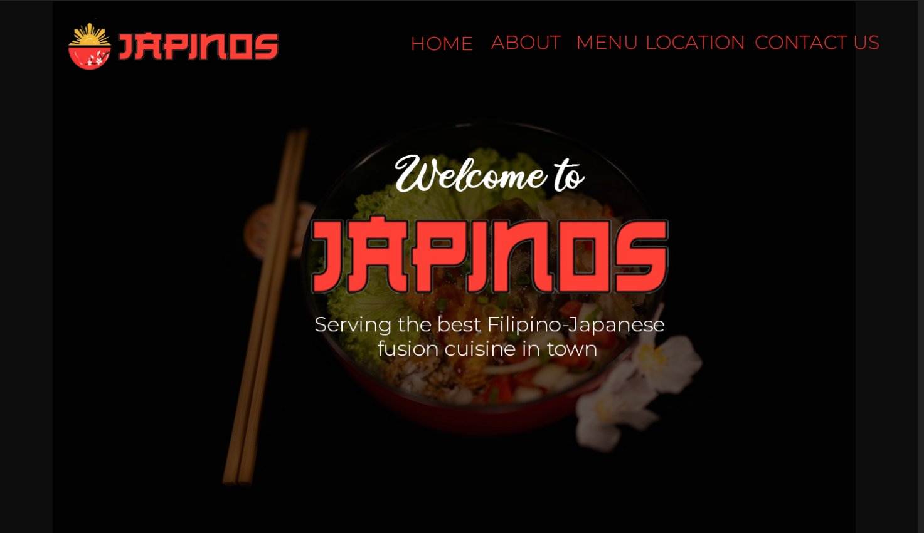**

The message “Welcome to Japinos” and tagline is static. The background is a carousel a.k.a slideshow, we will feature different dishes from the menu in the background.

**DESIGN 2**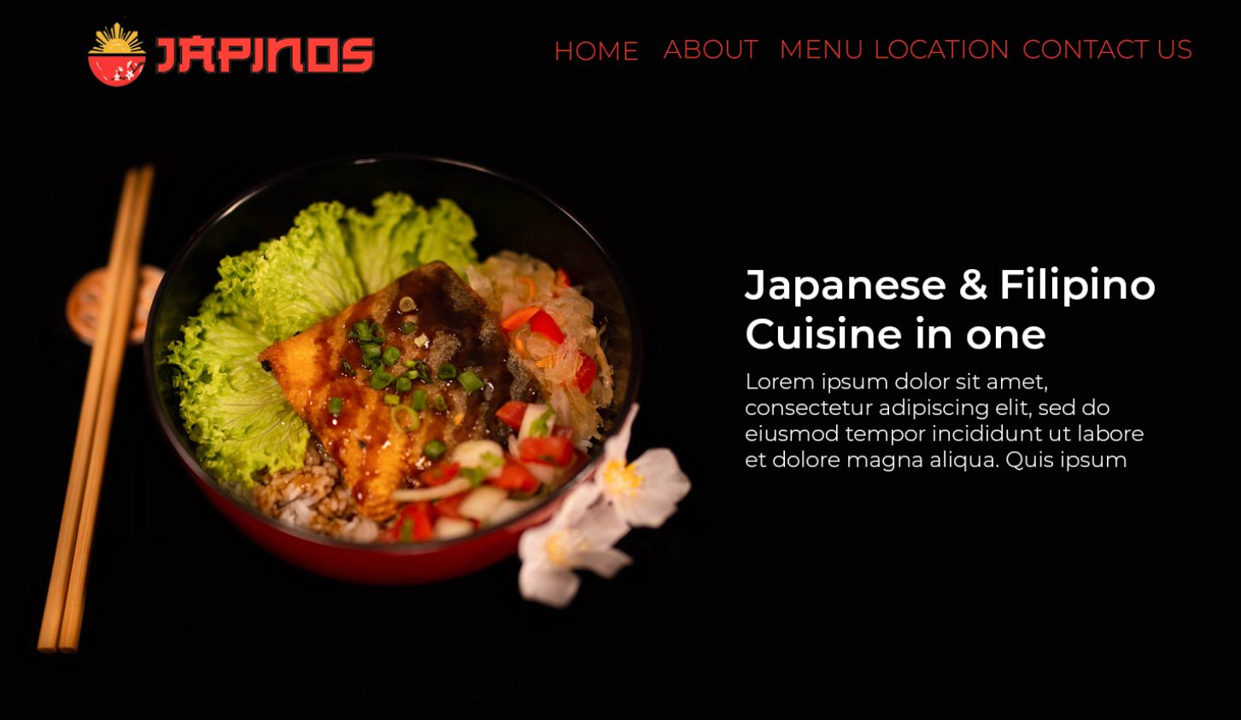

This design is also in carousel, we can feature the best dishes, promos and latest news in this design. I’m also planning to add in this slide that customers can now order in Japinos through foodpanda. It will look like this:   
  
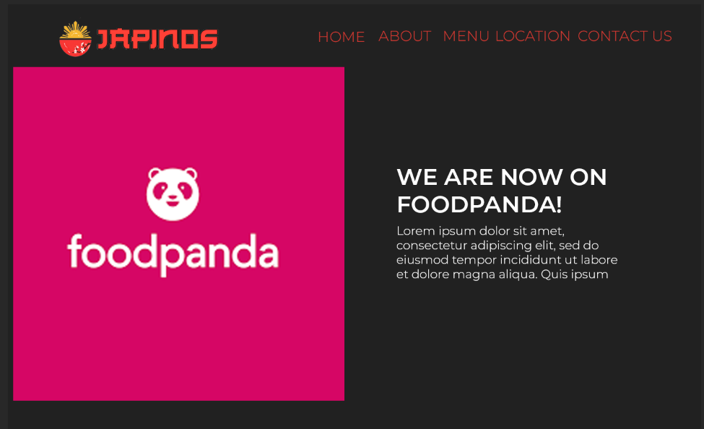

**About the restaurant:**

This section can contain anything about the restaurant or the history.

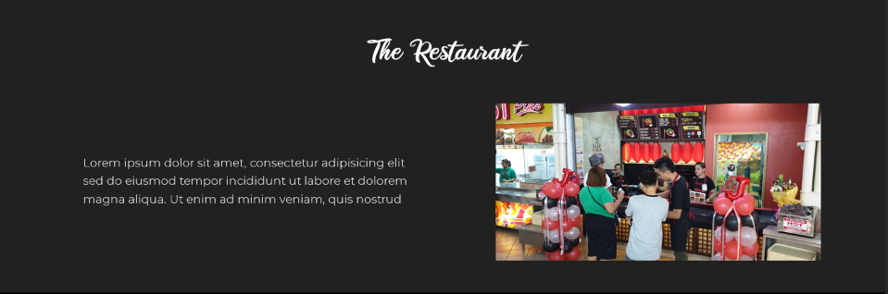

**MENU**

I put a specialized section for the best sellers of the restaurant to emphasize and promote these dishes.

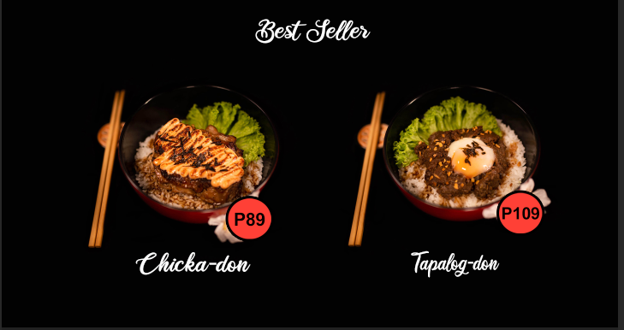

I have two designs for the menu:  
Design 1 (Static Design):

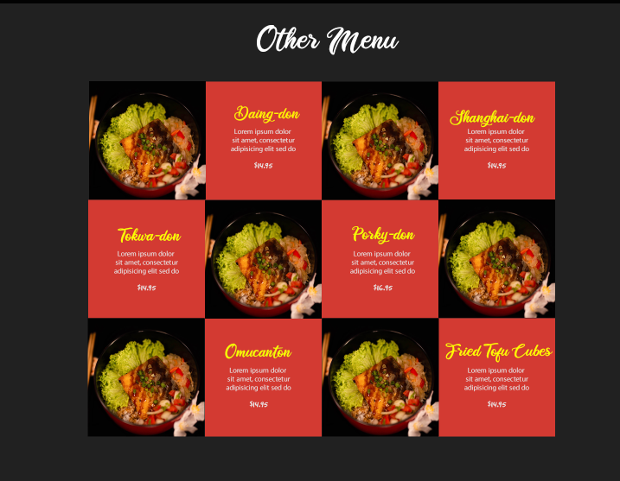

Design 2 (interactive design):

In this design each dishes will have a separate page of the book. Each page will give description, photo and the price of the menu. The page will flip when the user click the page.

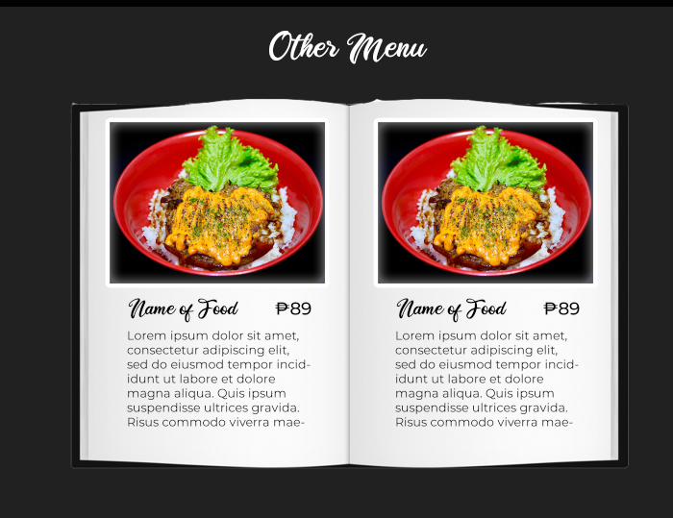

Testimonials

In this section, we will feature the best costumer reviews.

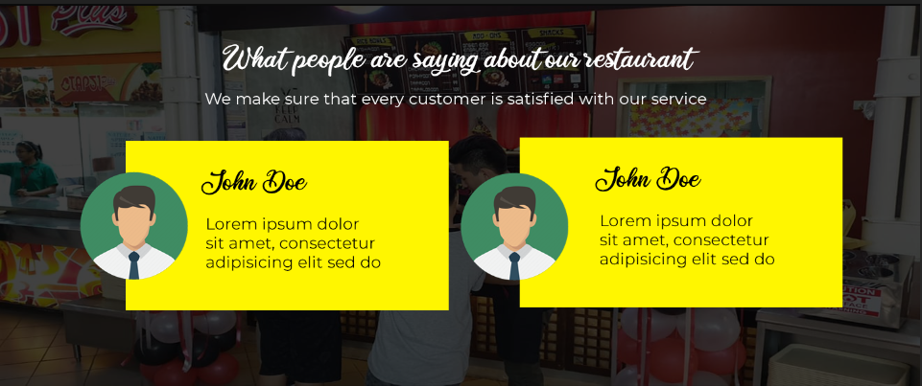

Location and Opening hours:

The user can interact with the google map so they can see how far they’re from the location of the restaurant.

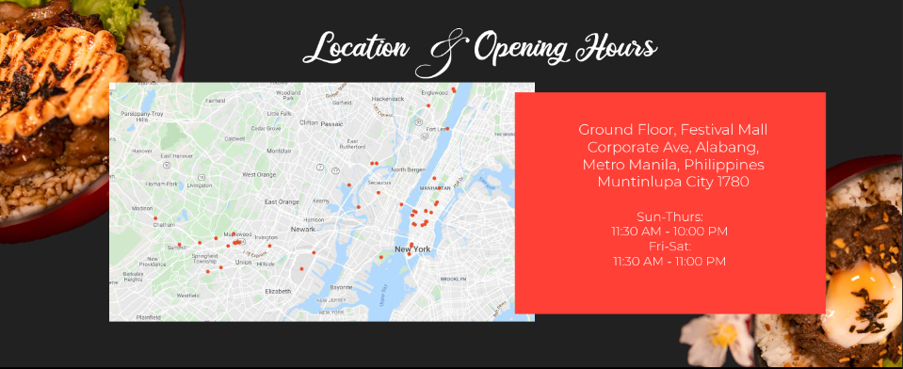

Team

I noticed from the facebook page that the admin featured the chef’s behind the amazing dishes of the restaurant, I added a section for them. We can write a short description about them here.

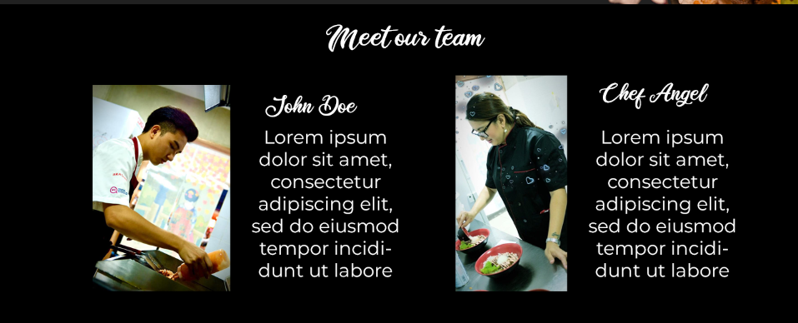

Contact Section:

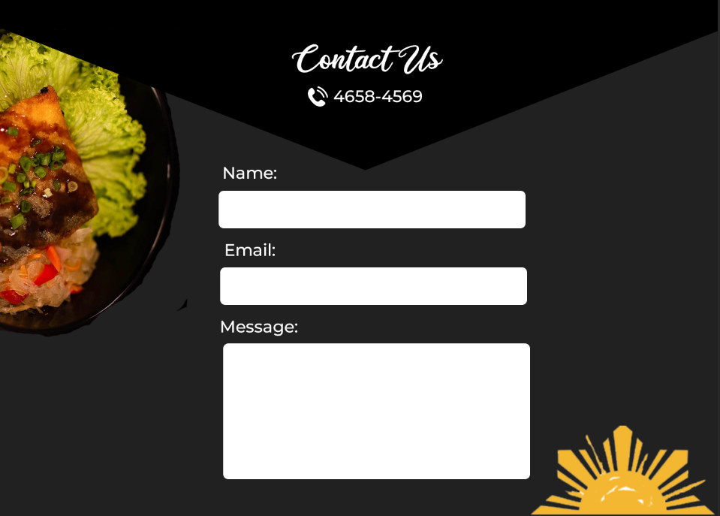

Footer:

The lorem ipsum under the word JAPINOS is about the restaurant. When the social media buttons are clicked, it will redirect to the facebook page and Instagram page.

